# BWAPP Installation

## Installing Buggy Web Application (BWAPP) on Virtualbox.

What is Virtualbox?

VirtualBox is a free and open-source hosted hypervisor for x86 virtualization, developed by Oracle Corporation.

How to install Virtualbox?

1. Go to [www.virtualbox.org](http://www.virtualbox.org)
2. Download the current version of Virtualbox for your Operating System (OS)
3. Once finish downloading, begin installation process.
4. Double click on the box icon: Virtualbox.pkg 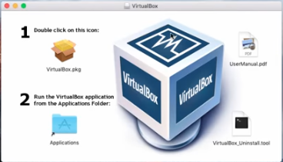
5. Follow the on screen instructions and click **“continue”**
6. Once you click continue you should see a screen displaying how much space Virtualbox will take up on your computer 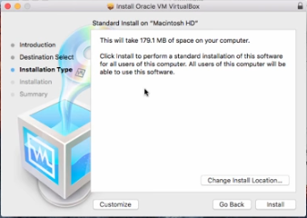
7. Click **“install”**
8. Once its finished you should see a green checkmark showing that installation was successful.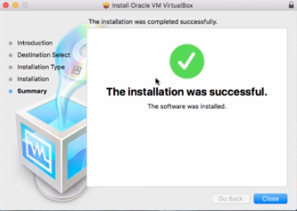
9. Close Window

Launch Virtualbox & Create an Image?

1. Find the Virtualbox icon and Launch it.
2. You should see an empty environment like this:

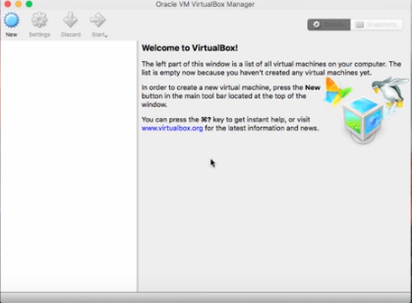

1. Click on the Blue Button in the left hand corner that says **“New”**
2. Another screen should pop up displaying information for the new image.

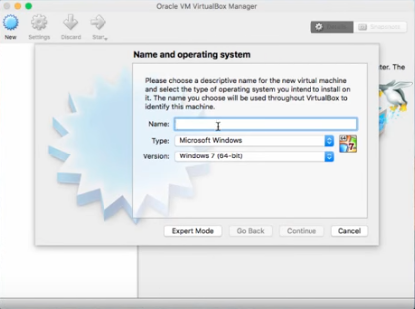

Installing Buggy Web Application (BWAPP)?

1. Go to any search engine and type in **“bwapp”**

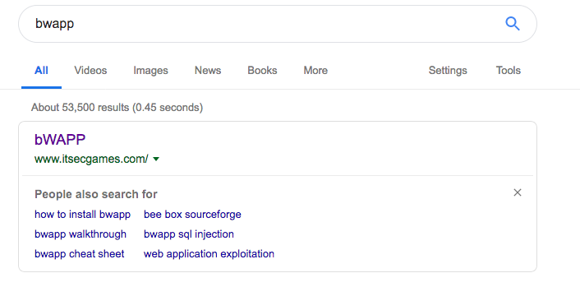

1. Click on the [www.itsecgames.com](http://www.itsecgames.com) on the search engine
2. Once on the site select “Download” page
3. Once on the Download page, click on the bold **“here”**
4. You should be taken to:<https://sourceforge.net/projects/bwapp/files/bWAPP/>
5. Select the current bWAPP version folder

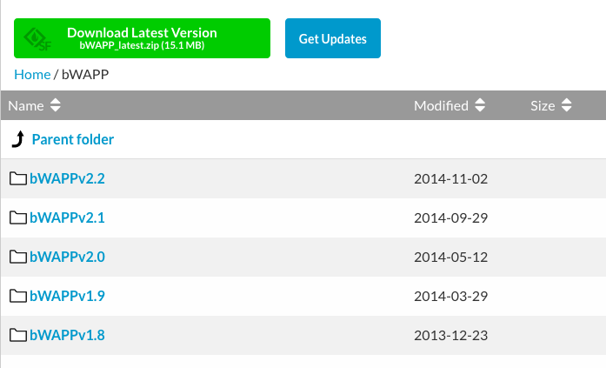

1. Select the zip folder from downloads
2. Extract the zip file

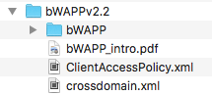

1. Open Virtualbox & create a new Virtual machine and click **“Next”**
2. On the next screen adjust the memory size, 1024 MB should do, then click **“Next”**

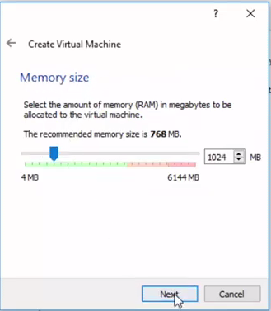

1. You should be taken to the **“The Hard Disk Screen”**

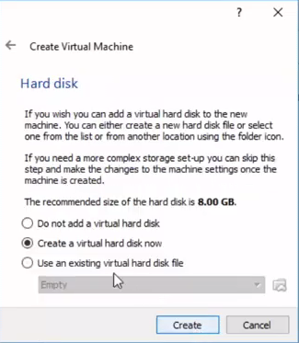

1. Choose **“Use an existing virtual hard disk file”**

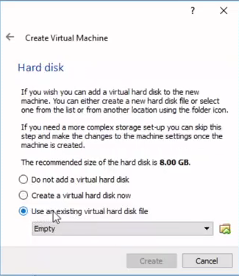

1. In the folder select the downloaded **“bee-box”** file

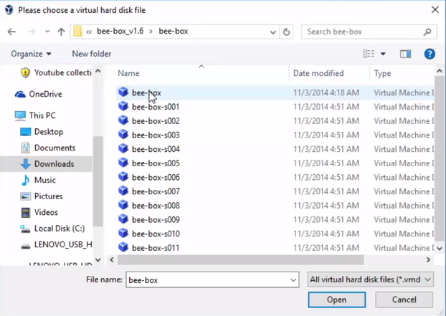

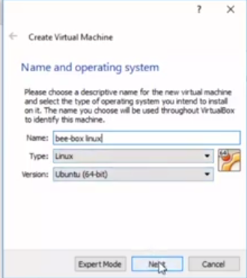

1. Once selected, click **“Create”**
2. You should see the created machine in Virtualbox: **“beebox”**

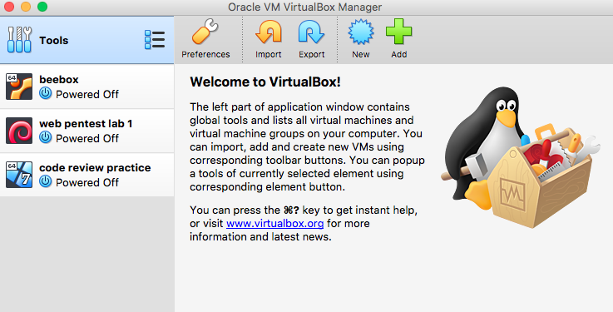

Starting Buggy Web Application (BWAPP)?

1. Start the machine
2. You should see the **“itsec games”** screen

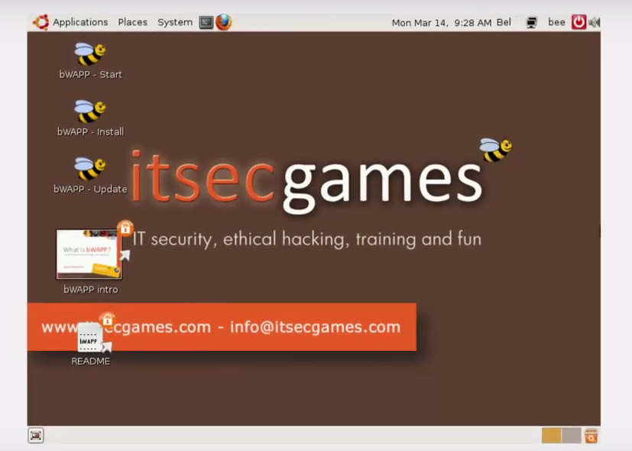

1. Okay now click on the terminal icon and type ‘**ifconfig**‘ command to get your server address.

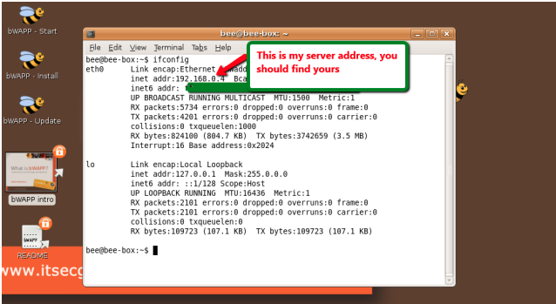

1. Now open your browser in your windows machine and type the <http://server> IP Address/bWAPP/login.php. **(ex: http://localhost:1025/bWAPP/login.php)**

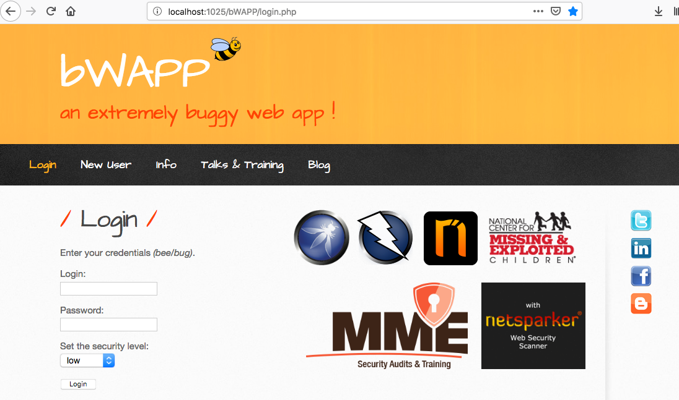

Happy Hacking